NUMPY PROGRAMS

AIM
To write a Python program using the NumPy library to create and display 1D and 2D arrays, zeros array, ones array, identity matrix, and a range of values.

ALGORITHM
- Start the program.
- Import the NumPy library using import numpy as np.
- Create and display a 1D array containing elements from 1 to 5.
- Create and display a 2D array containing two rows and three columns.
- Create and display a 3×33×3 array filled with zeros using np.zeros().
- Create and display a 2×42×4 array filled with ones using np.ones().
- Create and display a 3×33×3 identity matrix using np.eye().
- Generate and display even numbers from 0 to 8 using np.arange(0, 10, 2).
- Stop the program.

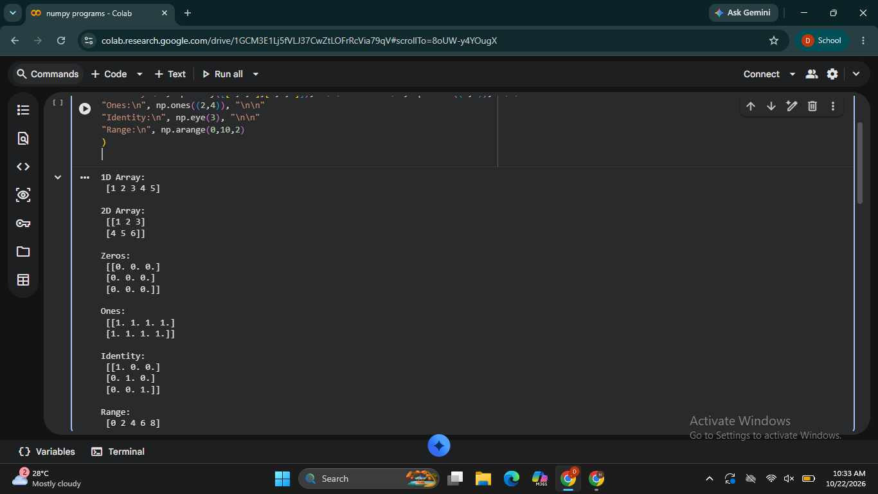

RESULT
Thus, the Python program using NumPy was executed to create and display different types of arrays, including 1D and 2D arrays, zeros array, ones array, identity matrix, and a range of values.

